**CN LAN 06**

**BASIL ALI KHAN**

**20K-0477**

**Task#01:**

Four Fields:

1. Source Port
2. Destination Port
3. Length
4. Checksum

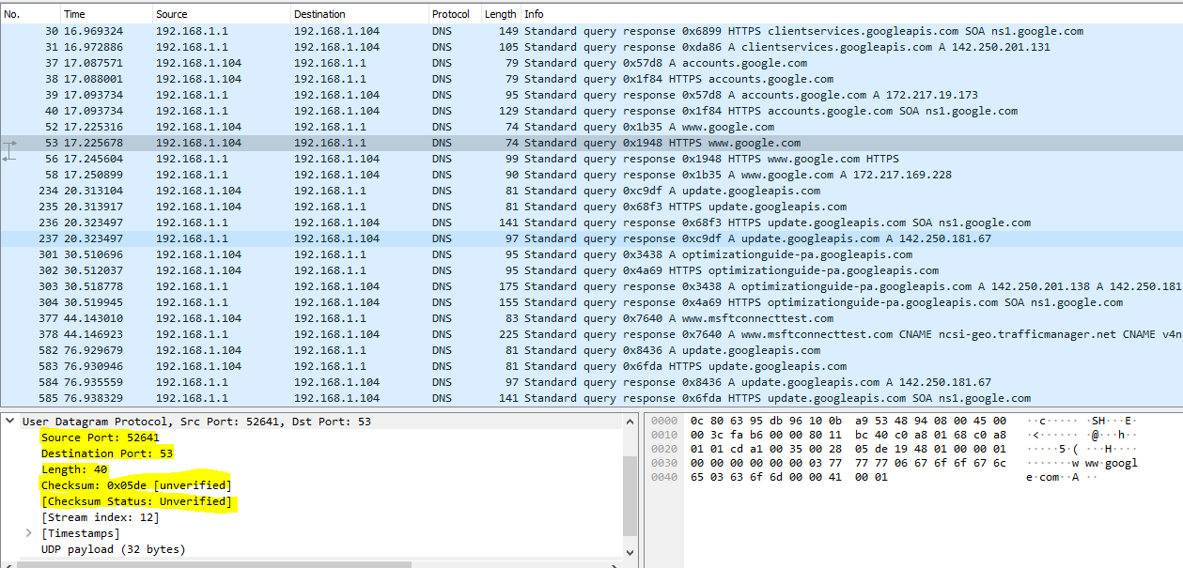

**Task#02:**

UDP header has fixed length of 8 bytes. Each of these 4 header fields is 2 bytes long.

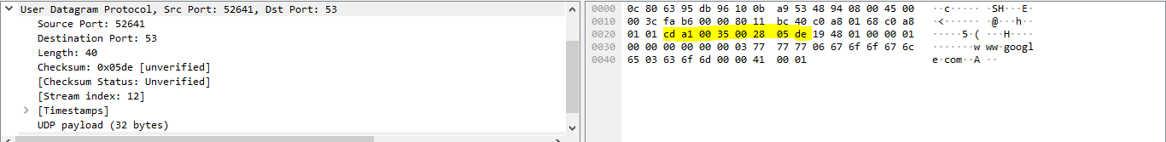

**Task#03:**

40 bytes - 8 bytes = 32 bytes

The length of UDP payload is 32 bytes.

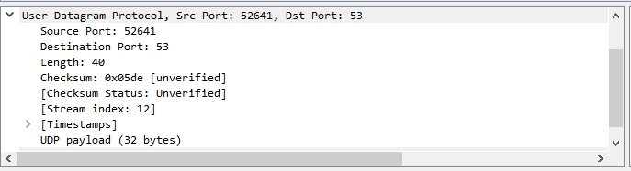

**Task#04:**

(2^16 – 1) = 65536 – 1 = 65535

The maximum number of bytes are:

65535 – 8 = 65527 bytes

**Task#05:**

The largest possible source port number is:

(2^16 – 1) = 65536 – 1 = 65535

**Task#06:**

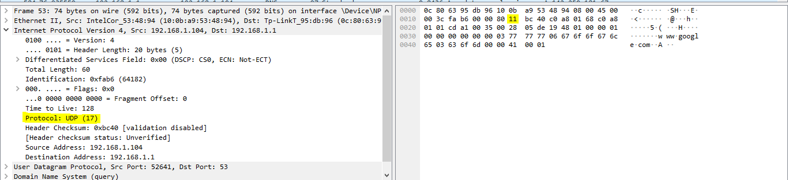

**Task#07:**

* The source port of UDP packet send by host is same as the destination port of reply packet.
* The destination port of UDP packet send by host is same as the source port of reply packet.

